BMQG BLOCK OF THE MONTH
NOVEMBER 2015 - DELECTABLE MOUNTAINS
COLOURS: Blues, purple-blues, green-blues, nothing glaringly bright, one lighter fabric (mountain) and one darker fabric (night sky) for good contrast.

CUTTING (slightly oversized so you can square them up):
Cut two 8 3/4" squares, one of each colour fabric

This block's dimensions are 8" x 12.5" to finish at 7.5" x 12"
1
There is an online tutorial with layout ideas at: http://quiltville.blogspot.ca/2005/06/scrappy-mountain-majesties.html
(copyrighted information used with permission of author, Bonnie K Hunter)

Lay the two squares of fabric right sides together. Mark the lighter fabric with a diagonal from one corner to the other and sew 1/4" away from it on each side (dotted lines in image 1).

Cut down the marked diagonal line, giving you two half-square triangles. Open each one and iron the seam to the dark side. Square up each half-square triangle to 8" square.
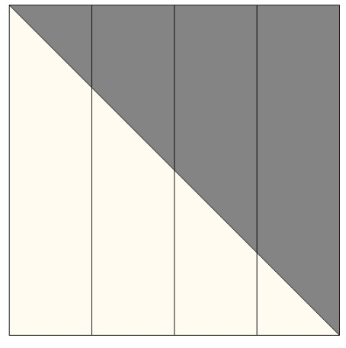
2
Lay the two half square triangles right sides together with dark against the light on both sides, nesting the seams.

Keeping them lined up, cut the half square triangles into four 2" strips (image 2).

There will be two strips in each stack, one the reverse of the other. Separate them and place the two reversed block halves next to each other.

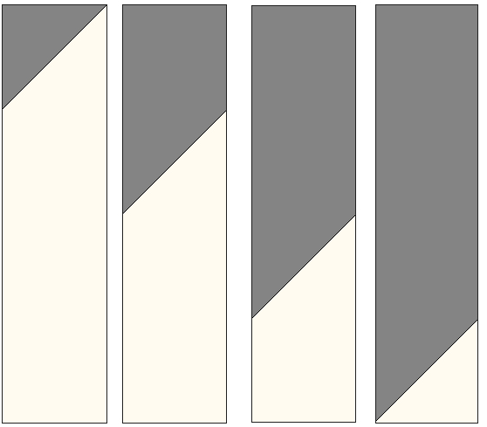
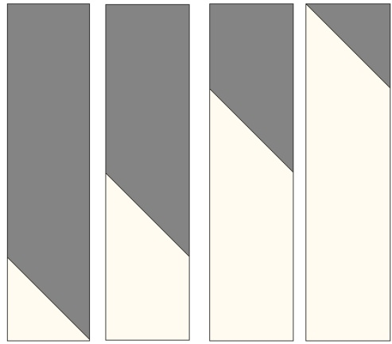
For one block half, switch the places of the two outer strips, then switch the two inner strips. Repeat for the other block half. (image 3).
3

Maintaining the jagged mountain design, sew the strips of each block half together .

Sew the two block halves together at the longer edge of the lighter fabric as in the sample block above.

Iron the seams to one side.

