BMQG BLOCK OF THE MONTH
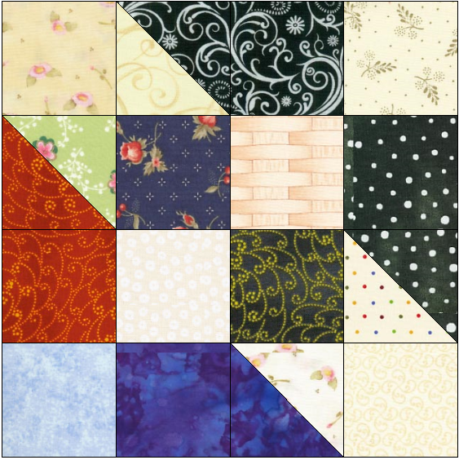
DECEMBER 2015 - SCRAPPY ROAD TO OKLAHOMA
L
L
COLOURS: Scrappy: small amounts of blues, greens, reds, purples, yellows but the darks must have very good contrast with the lights - avoid medium fabrics
L
10 different light fabrics (marked L in sample block)
L
L
6 different dark fabrics

CUTTING:
Cut one 2 1/2 inch square from each of the 10 light fabrics
Cut one 2 1/2 inch square from two of the 6 dark fabrics
Cut one 4 1/2 x 2 1/2 inch rectangle from four of the 6 dark fabrics
L
L
L
This block's dimensions are 8.5 x 8.5 to finish at 8x8 inches
L
L

Finger-press the back side of four of the light 2 1/2 inch squares diagonally from one corner to the other.

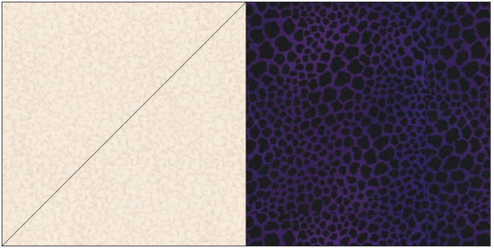
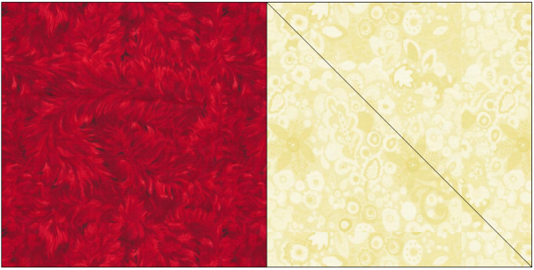
Referring to the images below, lay two of the marked light squares right sides together on the ends of two of the dark rectangles. Then lay the other two marked light squares right sides together on the opposite ends of the other two dark rectangles. Pin if you like so they don't slip.
Note how the marked lines are going 'up the hill' on the left and then 'down the hill' on the right. There will be two 'uphill' ones and two 'downhill' ones.
waste
waste

Sew on the marked lines. Cut away the upper corners (marked waste in the diagram) 1/4 in from the seam. Iron the seam to the dark side.

Use the sample block diagram's arrangement of light and dark squares and rectangles (top and bottom in opposite directions; right and left sides in opposite directions) to lay out the block in sewing order.

Sew the middle four-patch first. Iron the seams to one side. Lay it back down in the correct orientation of lights and darks.

Sew into three vertical strips. Then sew those strips into the blocks. Iron the seams to one side.

