BMQG BLOCK OF THE MONTH
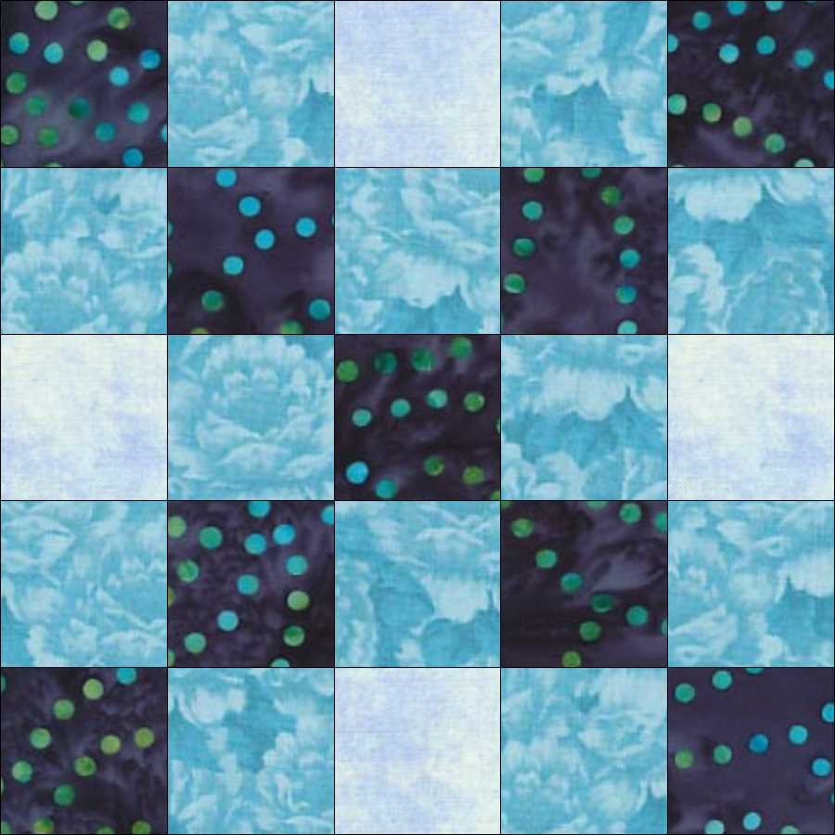
JANUARY 2016 - Blue Chains Revised

COLOURS :
Small amounts of 3 blue fabrics, one dark, one medium, one light

CUTTING:
Dark Fabric: cut one 3x27" strip - cut this strip into one 3x3" square and one 3x24" strip
Medium Fabric: cut one 3x36" strip - cut this strip into one 3x12" strip and one 3x24" strip
Light Fabric: cut one 3x 12" strip

This block's dimensions are 13 x 13 to finish at 12.5x12.5 inches
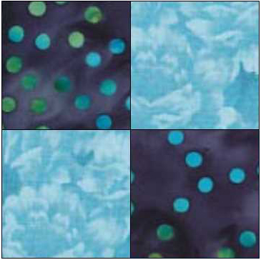
Use 1/4" seams throughout.

Sew the 3x24" dark and medium strips with their right sides together.
Iron this strip set open with the seam allowances towards the dark sides.
Cut the resulting strip set into eight 5 1/2x3" sections.
Lay one section down right side up and put another section right side down on top of it, butting up the seams and keeping the light on dark and dark on light.
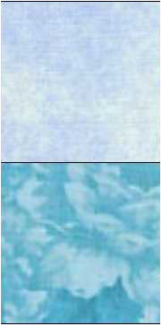
Being careful to match the seams, sew the two sections together. Open out and press the seam allowances to one side, it doesn't matter which.

Sew the 3x12" medium and light strips with their right sides together.
Press the seam allowances to the light side.
Cut this strip set into four 5 1/2 x 3" sections.

Arrange the Dark/Medium and Medium/Light
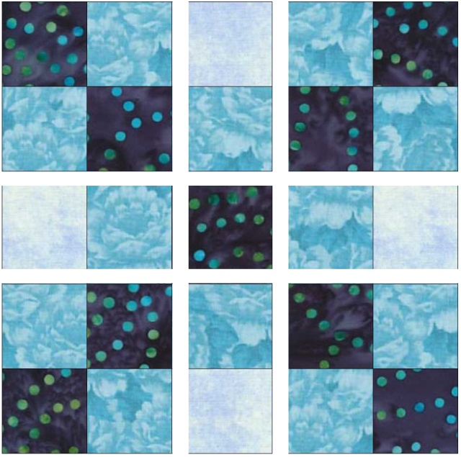
sections and the single Dark square in this way:
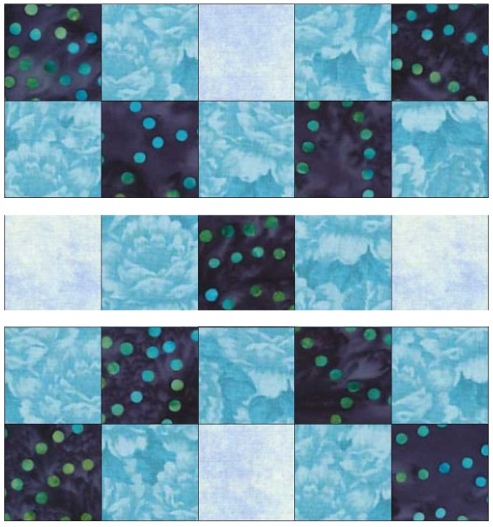
Sew horizontal rows, matching seams - if the seam allowances are on the same sides, rotate the 4-patch 180 degrees.

Press the wider strips' seams away from the middle. Press the narrower strip's seams toward the middle.

Complete: sew the vertical rows, again matching the seams. Press the seam allowances to one side.

